Partnership Contract

# TGP Pair Project

## Nature of the Contract

This partnership agreement between Jennifer Field and Joshua Calvert for the Pair Assignment in Technical Games Production is in effect for the entire period beginning November 5th and terminating at the end of January 6th prompt.

This document exists as formal evidence of the above parties’ wish to associate themselves as partners in business. This document will also dictate the terms and standards agreed to be upheld for the entire duration of the partnership.

## Share of Intellectual Property

While this contract is in effect, the partners will produce a Video Game or Video Game Prototype to be submitted towards their grade. The initial share of the Intellectual Property (IP) is 50:50.

Either party may appeal for a fair larger share of the IP, and this must be granted when supported by sufficient evidence of a breach of this contract.

## Split of Workload

All tasks are to be split evenly between the partners. If one partner is struggling, the other may assist and if absolutely necessary, take over from where they left off. This is to be decided between the partners on a case-by-case basis, but each partner must have at least one task assigned to them at any one time.

## Decisions

Any decisions relevant to the project are to be discussed between partners until an agreement is reached.

If an agreement cannot be reached by this method, then a tutor must be asked for their thoughts on what would be best. This advice must be followed unless both parties agree on an earlier suggestion.

## Obligations of Work

At the bare minimum, partners are required to turn up to the Technical Games Production tutorial on Thursday to do work. However, they are expected to do extra work outside of this time whenever possible. Failure to uphold these obligations may result in forfeiting a fair share of the IP at the other partners’ request.

## Obligations of Meetings

Meetings are to take place weekly in the Technical Games Production tutorial on Thursday. Other communication includes messages via Discord or Facebook. Any major decisions or points raised through these alternate methods of communication are to be recorded in the Trello Board or GitHub where necessary.

## Failure to Comply

Failure to comply will result in vicious mockery, formally made through the peer assessment form, a reduced grade and the possible forfeit of the failed party’s portion of the IP. In extreme cases, this can also result in failure of the overall assignment.

## Signed

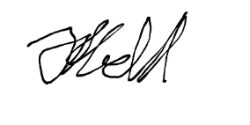Jennifer Field

X _ _ _ _ _ _ _ _ _ _ _ _

Joshua Calvert

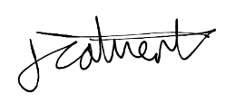

X _ _ _ _ _ _ _ _ _ _ _ _